A.M.J. SPOT WELDER V1

The 2-pulse spot welder of the Erdőkertesi Microcontroller Club. www.2113.hu

Settings:
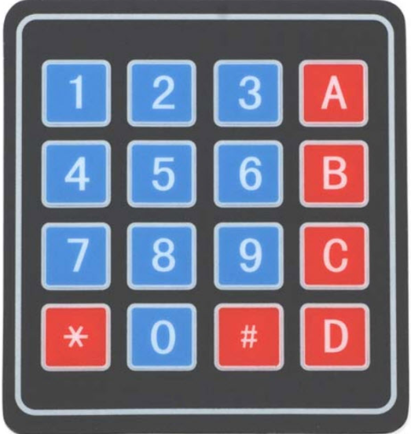
1: Select preheating time
2: Selecting the time between preheating and spot welding
3: Selecting spot welding time
4: Adding value 1 ms (+1)
7: Decrease value 1 ms (-1)
5: Adding value 5 ms (+5)
8: Decrease value 5 ms (-5)
6: Adding value 10 ms (+10)
9: Decrease value 10 ms (-10)
0: Reset values to zero(0,0,0)
*: Spot welding test
#: Turning on the fan
A: Pre-programmed mode(60,50,110)
B: Pre-programmed mode(70,50,120)
C: Pre-programmed mode(80,50,130)
D: Pre-programmed mode(90,50,140)

© 2024 Erdőkertesi Mikrokontroller Klub

